|  |  |  |  |
| --- | --- | --- | --- |
| 1 | | 0.0 | |
| NUMERO DE FRONTERAS | | ENERGIA AGREGADA | |
|  | | | |
| NO | | 0 | |
| CONTRATO | | VENCIMIENTO CONTRATO | |
|  | | | |
| 4,994,116 | 94 | | 188,716 |
| INGRESO 2019 | DÍAS CERTIFICADOS 2019 | | ENERGIA RESPALDADA 2019 |
|  | | | |
| 2,520,857 | 48 | | 89,946 |
| INGRESO 2020 | DÍAS CERTIFICADOS 2020 | | ENERGIA RESPALDADA 2020 |

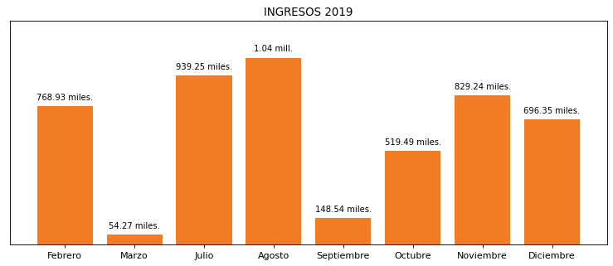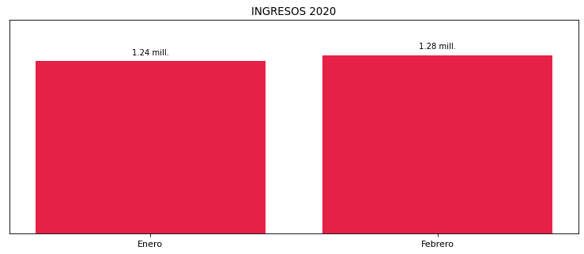

|  |
| --- |
| **HAMPTON MEDELLIN**  USUARIO |

|  |
| --- |
| **Mateo Porras**  Ejecutivo de cuenta |

|  |
| --- |
| **Julian Avila / Director de Gestión de Activos / javila@metro-op.com**  Primera fecha: PUNTO FOCAL |

|  |  |  |  |  |  |  |  |  |  |
| --- | --- | --- | --- | --- | --- | --- | --- | --- | --- |
| **FRONTERA COMERCIAL** | **TIPO DDV** | **COD SIC** | **PREDIO** | **PROMEDIO** | **MARGEN** | **ÚLTIMA DESCONEXION** | **DÍAS CERTIFICADOS** | **ACTUALIZACION** | **PROXIMA PRUEBA DDV** |